# 2024 Web & Database Computing – Group 64

Project Research Document

## Design Goals

The purpose of the web application to be designed is to host a web application for a single volunteer organization, with branches across Australia. The web app will have a login feature, with distinct roles between volunteers and managers, the latter of which will have various additional abilities to oversee several administrative tasks.

## Design Principles

There are many well-known and well-documented design principles that are guidelines for all web applications to follow, in the pursuit of high user engagement. These mainly relate to how interactive elements are placed on the web page, and adhering to common conventions such that some key features are clearly communicated.

Some principles outlined by the Mozilla Web Docs (Mozilla, 2024) include:

* Cross-browser compatibility
* Responsive web design
* Performance
* Accessibility
* Privacy & Security

While these are very broad, they capture the general idea of concepts to keep in mind when designing a web page for user interaction. Cross-compatibility and accessibility ensure that any user should be able to access the web page, while performance and responsive design aim to maximise the ease of use (and thus user retention) of the site. Privacy and security refer to proper handling of data being sent to and from the user, and so the use of secure protocols in a thorough way.

Some other well-known principles which apply well to our project include (Yablonski, 2024):

* Fitt’s Law – ‘The time to acquire a target is a function of the distance to and size of the target’
  + Primarily relating to kinematic load, it should be ensured that action items are generally grouped together, or otherwise take up significant space on the page
  + However, avoid clumping items too close, as this can result in poor accuracy
* Hick’s Law – ‘The time it takes to make a decision increases with the number and complexity of choices’
  + Primarily relating to cognitive load, it should be ensured that the user is not overwhelmed with action items on any one page
  + For tasks requiring thought (eg. Filling out a form), keep choices minimal, or otherwise well-segmented, to promote thoughtful responses
  + However, avoid oversimplification – if necessary, gradually increase the number of available options
* Jakob’s Law – ‘Users spend most of their time on other sites … users prefer your site to work the same way as all the other sites they already know’
  + Utilise common convention for design, and have action items behave predictably
  + Also ensure that items which are common are placed where the user expects them
    - Eg. Navigation, account details, logo
* Law of Common Region – ‘Elements tend to be perceived into groups if they are sharing an area with a clearly defined boundary’
  + In our case, this mostly relates to separation of text items on the page
  + Blog posts can be captured in a boundary, as can a navigation bar

These laws will be important in designing a functional, attractive website, as well as for observing the strengths and weaknesses of websites with similar goals which will be investigated in the next section.

## Example Web Pages

As our project aims to deliver a website for a volunteer organization to host branches and related events, we found it most effective to research websites with similar goals to understand how our design could be guided by as well as improve upon that of existing websites.

The most direct example given is *Foodbank* (foodbank.com.au).

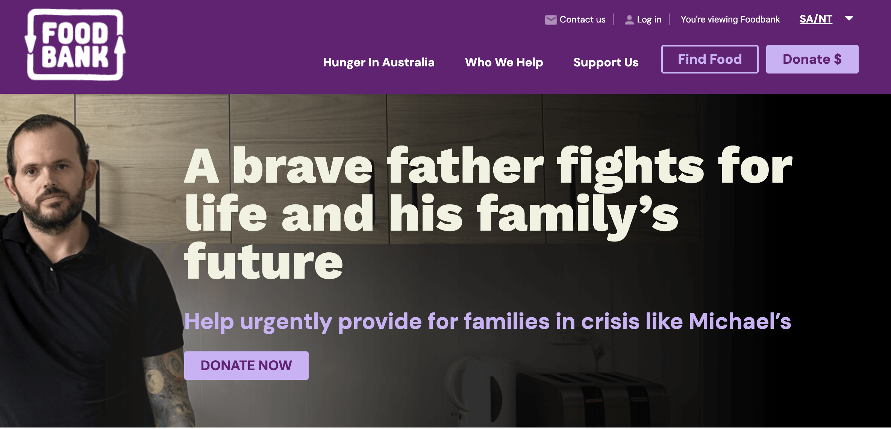

Figure 1: Foodbank home page

Several things of note are present in the landing page:

* Purple colour scheme
  + Logo with meaningful design
* Attention-grabbing visual with caption
* Call to action
  + (DONATE NOW)
* Login portal
* Several navigation options
  + Contact page
  + About page
  + Support page

Most of these key features directly assist with the website’s goal, by giving the user a quick description of what the organization does, as well as a donate option as a direct call to action. Furthermore, the navigation panel at the top offers a few attention-grabbing page titles that the user can easily access for further information.

With respect to kinematic and cognitive load, the design here is relatively simple – kinematic load is minimized by having all but one of the on-screen buttons kept to the top-right section of the screen. Similarly, the cognitive load is largely focused on the splash graphic at the center of the homepage, where the large and bold text is attention-grabbing and makes understanding the purpose of *Foodbank* simple.

As far as functionality is concerned, also present in this example are the login and contact forms, located near the other action buttons in the top-right corner, together with the branch location.

To further investigate *Foodbank*, clicking on the ‘Contact us’ link redirects to another page:

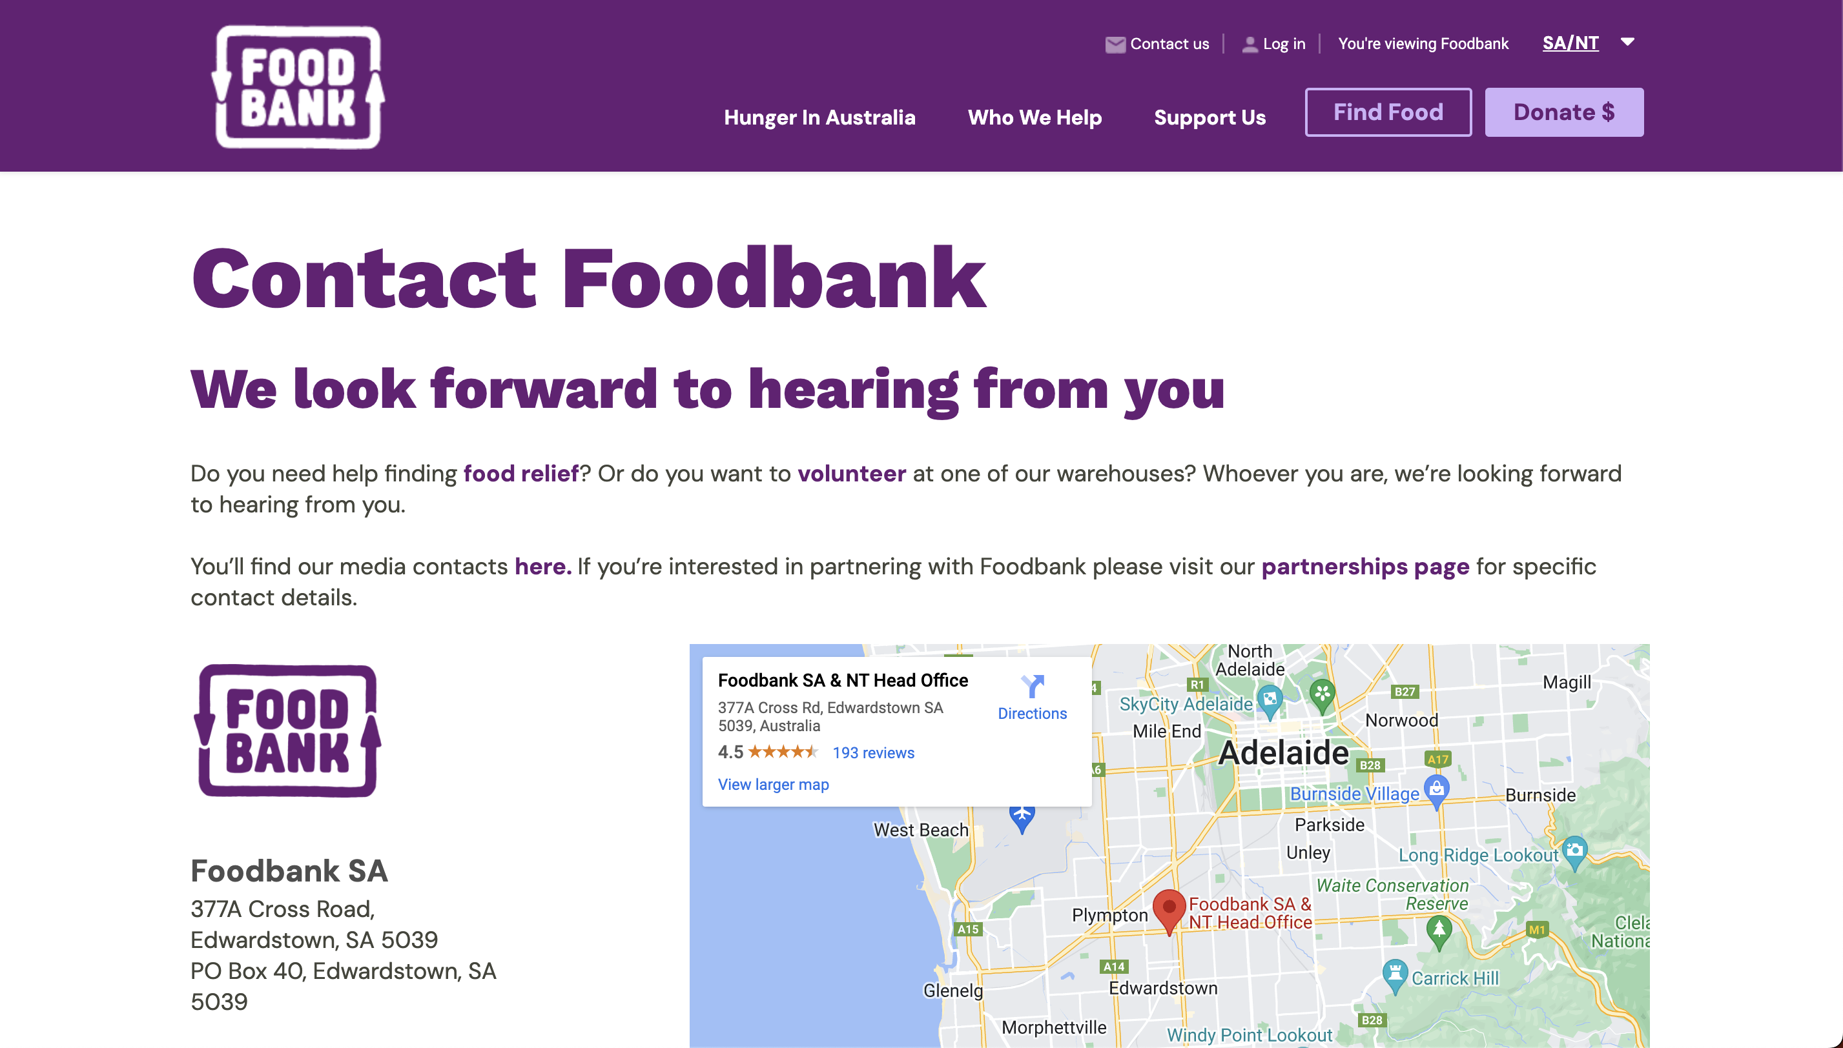

Figure 2: Foodbank 'Contact us' Page

Again, several items stand out

* Bold title and subtitle to reinforce the broad intent of this area of the web app
  + Which is expanded on in a brief body paragraph discussing specifics
* An address panel which conforms to expected style
  + Business name, followed by physical and postal addresses
* Embedded Google Maps pane
* Business hours (not pictured)

With additional locations on scroll:

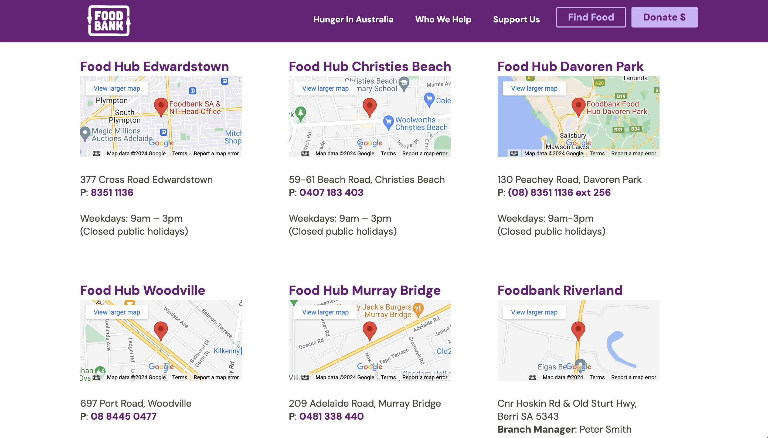

Figure 3: Foodbank 'Contact us' Page (bottom)

* Several embedded Google Maps panes for navigation
* As well as contact details and business hours

The most effective thing about this page is the immediate information about the main South Australian branch. Being a ‘Contact us’ page, however, it is interesting that there are no direct contact options at first loading the page – only when scrolling down. The hyperlinks in the short body text may be effective at otherwise directing users to more helpful pages, but perhaps an email or telephone number should be available at first glance, rather than requiring a scroll.

The use of an embedded Google Maps pane is also effective for the main location, however having such a system for all the ‘Food Hub’ locations is quite a lot of visual information, and it may be more useful to have these as clickable options to show/hide the Maps pane, or even simply provide external links to open Maps in a new tab.

Key functionality on this page mainly revolves around giving locations for the various Foodbank locations around the local area of the user, utilising embeds and standard address formatting. Potential areas of improvement include having phone number and emails at the front of the page, and reducing visual clutter of many different maps.

As a final example from Foodbank, the ‘Log in’ page is shown:

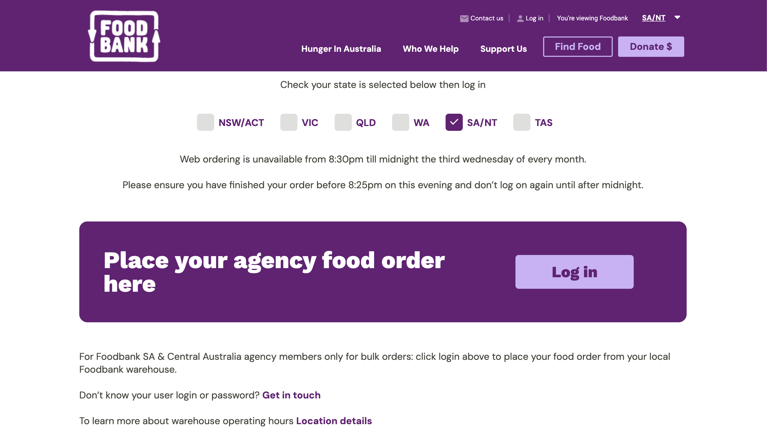

Figure 4: Foodbank Login Page

* Checkbox to confirm the user is logging in to the right branch location
  + Check marks usually indicate multiple options can be selected – this convention is not utilised here
* A second log in button

The main purpose of this page is confusing, as there is no direct log in form which would be expected from navigating to such a page. Instead, confusing clarifications are presented together with a secondary log in portal. ‘Web ordering is unavailable … the third Wednesday of every month’ is a confusing condition which, while perhaps intended to advise of typical online maintenance hours, does little more than complicate the process. This could perhaps be replaced by some form of JavaScript which presents an exact date and time of maintenance, and perhaps only shown within one week of the timeframe.

The log in portal which follows is quite basic

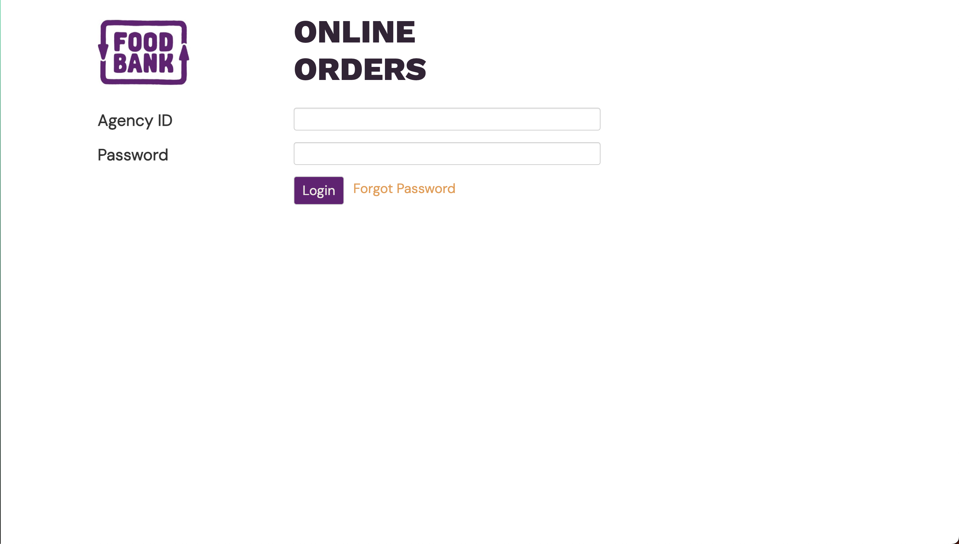

Figure 5: Foodbank SA/NT Login Page

While the functionality of the page remains, the appearance of the web page is a drastic change from that which preceded it, losing the top banner and centred text consistency. The page is quite empty, mostly filled with white space. This makes it appear unfinished – and so quite unappealing. For a login page which is likely to be viewed only once for a user, this is somewhat understandable, although it is quite a jarring change. Notably, this design for the login page is unique to the SA/NT branch, as other regions have a more well-designed page:

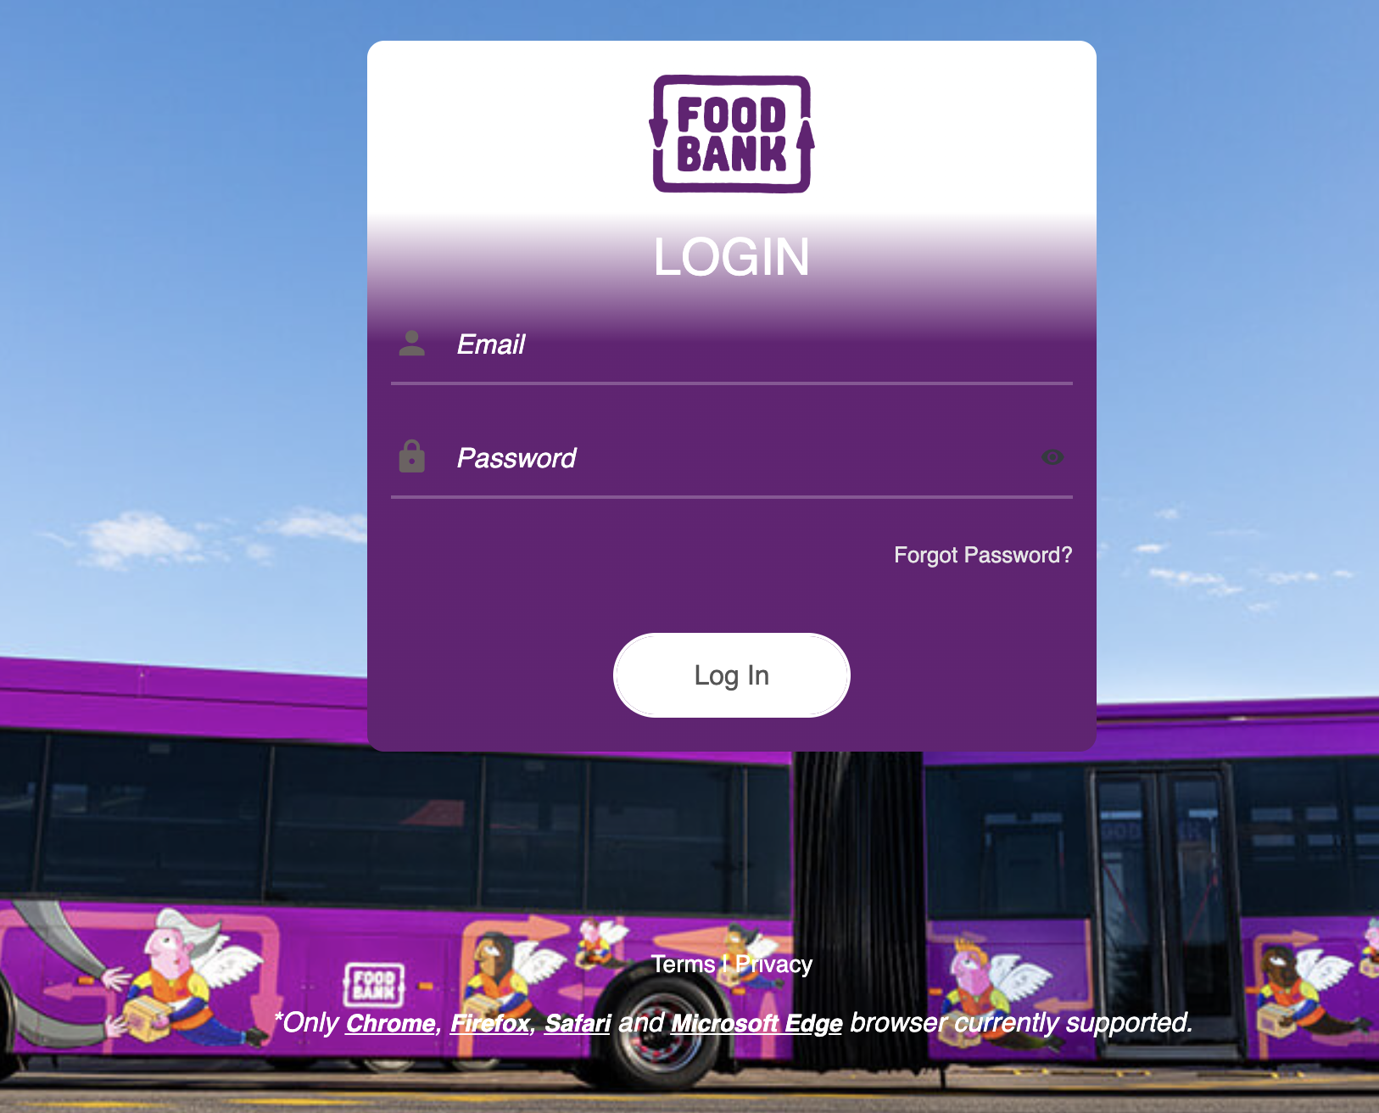

Figure 6: Foodbank VIC Login Page

## Comparison

To gauge the extent to which Foodbank is a good general example for our web app, here we present additional examples of web pages which are intended to serve similar purposes.

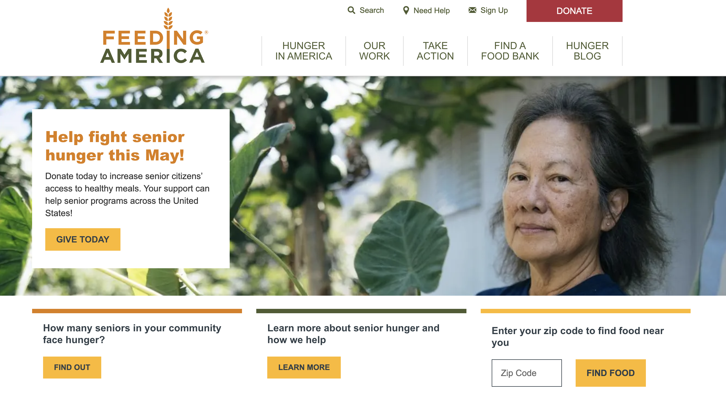

Figure 7: Feeding America homepage

This example, based on the charity *Feeding America,* provides an example of the consistent language of web design across countries, at least in the English-speaking world. Similar to *Foodbank*, the logo is present in the top-left corner, with the navigation menu present at the top of the page. The attention-grabbing splash image is here, again with the call to action ‘GIVE TODAY’ button associated. Login (signup) and contact (Need Help) options are again present in the top-right corner, reinforcing this as a general web standard. Here, however, the font style and colours are less impactful than Foodbank, and without the consistent colour theme of Foodbank’s purple. This comparison makes it clear that the format discussed above is commonly expected across web sites, as well as provides an example of how the impactful colour scheme and font styles of Foodbank assist in presenting an attractive page.

## Takeaways

The Foodbank example illustrates conventional design for a charity/volunteer organisation, showing how our design should likely adhere to this common design, based on Jakob’s principle. Then, following the law of common region, it would be desirable to keep navigational items to the top of the page, and utilise clear boundaries to separate this from the page’s main content. Hick’s law is applied on Foodbank’s home page by having only one highlighted action item in the centre of the page for donations, and keeping navigational items de-emphasised to minimise clutter. Finally, Fitt’s law can be utilised by again keeping navigational items near each other, yet separate enough to avoid misclicks, and ensuring important actions (such as for donations) are in large click areas.

## Administrator Management

In addition to presenting an attractive front-end for clients to understand the purpose of our organization, a secondary purpose of the web application is to manage the operations of individual branches of the organisation. To this extent, included functionalities are event creation, management and advertisement, addition and removal of users from certain branches, post and/or view general updates, personal information management and more. These responsibilities are to be divided between three distinct roles – users, branch managers and system admins, in order of escalating privilege. To facilitate the fulfilment of these separate responsibilities, the web app will include a dedicated user profile page, in which the details of the volunteer is outlined, with options to change one’s own details. Managers and admins will have more actions from a user page, much like a dedicated *admin panel*, where, for example, the status of all volunteers under the branch one manages can be seen.